**JSPM’s**

**Jayawant Institute of Management Studies**

**Tathawade, Pune-33**

**(NAAC Accredited “A” grade Institute, Approved by AICTE & Recognized by Savitribai Phule Pune University)**

**Academic Year 2020-21**

**MCA-I Semester:-IITC11: Mini Project**

**(Feb-May 2021)**

**Project Title:- Online Quize ……………………………………………………………………………………….**

**Name of the Student: - Rutuja Santosh Kadam …………………………………………………………..**

**Rollno:- 61291428**

**Note:- This is the Project Front Page of your Project.**

**INDEX**

|  |  |  |
| --- | --- | --- |
| **Sr. No.** | **Context** | **Page No.** |
| 1. | **Chapter I**  **Introduction**   * 1. Introduction to System   2. Existing System   3. Need for System   4. Scope of System   1.5 System Requirement  Hardware  Software |  |
| 2. | **Chapter II**  **Proposed System**  2.1 Proposed System  2.2 Objective of System  2.3 User Requirement  2.4 Modules of system  2.5 Module Hierarchy Diagram |  |
| 3. | **Chapter III**  **Analysis & Design**  3.1 Use-Case Diagram   * + 1. Admin use case     2. User use case   3.2 Class Diagram  3.3 Sequence Diagram  3.3.1 Admin sequence diagram   * + 1. User sequence diagram   3.4 Activity Diagram  3.4.1 Admin activity diagram  3.4.2 User activity diagram  3.5 Deployment Diagram  3.6 ERD  3.7 User Interface Diagram  3.8 Table Specifications |  |
| 4. | 4.1 Drawbacks & Limitations  4.2 Proposed Enhancement |  |
| 5. | **Conclusion** |  |
| 6. | **Bibliography** |  |

**Chapter I**

**Introduction**

**1.1 Introduction to System**

The ONLINE QUIZE is a web application for to take online quize in an efficient manner and no time wasting for checking the paper. The main objective of ONLINE QUIZE is to efficiently evaluate the candidate thoroughly through a fully automated system that not only saves lot of time but also gives fast results. For students they give papers according to their convenience and time and there is no need of using extra thing like paper, pen etc. This can be used in educational institutions as well as in corporate world. Can be used anywhere any time as it is a web based application(user location doesn’t matter). No restriction that examiner has to be present when the candidate takes the test.

In order to solve these problems, we have developed a Web-based online test system which can create quizzes competitively and collaboratively by students for the purpose of reducing the load required for a teacher and promoting interactions among students and between the teacher and students.

There are 2 modules in the project are as follows :-

1.Admin

2.User

**1.2 Existing System**

* The first problem is that there are loads of hard copied documents being generated.
* The existing system is manual system. Needs to be converted into automated system.
* Manual system face so many problem limitation avoid in new system.
* In existing system there are several problems that we faces in a common way. Some of those problems are:
* Manual system requires pen/ pencils and paper.
* Teacher needs to spend time to script checking.
* Student needs to wait to get their result up to the teacher finishes the script checking

**1.3 Need for System**

The development of the new system contains the following activities, which try to automate the entire process keeping in view of the database integration approach.

* User friendliness is provided in the application.
* The system makes the overall process much easier and flexible.
* To enable students to take exams anytime and anywhere.
* New system will process accurate results and also logistics cost is minimum..
* New system will be much better in performance as compared to existing one.

**1.4 Scope of System**

* This can be used in educational institutions as well as in corporate world.
* No restrictions that examiner has to be present when the candidate test the quize.
* Design to facilitate Admin and User.
* Results are obtained instantely- Users can see their results after completion of quize.
* Online quize can be easily accessed for 24/7 hours.
* Reduce exam anxiety amongst quize tackers – The flexibility associated with computer based quize reduces exam anxiety amongst quize tackers as they can tack the quize at any time of the day that coincides with their preferred sleep/weak cycle.
* This system is also useful to anyone to enhance their knowledge.

**1.5 System Requirement**

**Hardware Requirement:-**

**Server**

|  |  |
| --- | --- |
| **Name** | **Details** |
| **Processor** | Intel core i3 |
| **RAM** | 512 MB (or Above). |
| **HDD** | 4 GB (or Above). |

**Client**

|  |  |
| --- | --- |
| **Name** | **Details** |
| **Processor** | Intel core i3 |
| **RAM** | 512 MB (or Above). |
| **HDD** | 4 GB (or Above). |

**Software Requirement:-**

|  |  |
| --- | --- |
| **Name** | **Detail** |
| **Operating System** | Windows 7 or above |
| **Web Browser** | Browser Compatible |
| **Development Tool** | HTML,CSS,php,java script.bootstrap |
| **Database** | MySQL |

**Chapter II**

**Proposed System**

**2.1 Proposed System**

* This Web Application provides facility to conduct online examination.
* It saves time as it allows number of users to give the exam at a time and displays the results as the quize gets over, so no need to wait for the result.
* It is automatically generated by the server.
* Admin has a privilege to create and delete the quize.
* User can register, login and give the quize with his specific id, and can see the results as well.

**2.2 Objective of System**

* To reduce manual work.
* To remove drawback in manual working.
* To provide an interface through which student can appear for examination online for objective
* Objective answers will be checked automatically by the system from the database
* To provided user name and password  facility and  credentials should be checked properly at the time of login for user

**2.3 User Requirement**

* **Functional Requirements**
* The System should have user friendly user interface..
* According to role links are visible.
* It should take less time to perform action.
* The complete database resides in Server.
* **Operational Requirements**
* Proper validation checking at input time.
* Password is in encrypted format.
* For each role, the authentication (using Login ID and Password) is checked.
* Generate record according to the requirement.
* **Performance Requirements**
* The system should be such that it stores the user input in an efficient and secure way and make data available in proper format on screen.

**2.4 Modules of System**

* **User Registration -** This module is for the users who do not have their account. Here user is allowed to create an account to login. The account creation is done by filling the registration form with user details such as name, email,college name etc.
* **Admin-** The admin module leads to admin dashboard which is accessible through admin login and he/she able to see all the users and manage them. The admin dashboard allows admin to add new quize into system along with 4 options and 1 right answer and also admin can remove the quize. The admin can view ranking of quize as well as feedback given by users.

* **User-**The user can login to the system and view all the Quize and solve it.User can see history as well as ranking of the quize. User is able to give the feedback.

**2.4 Modules Hierarchy Diagram**

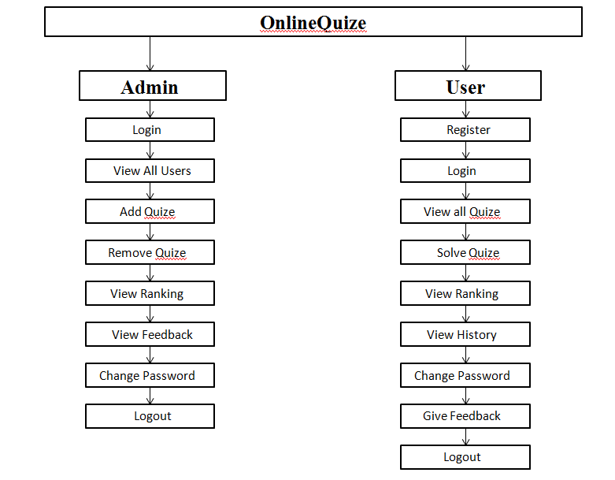

**Chapter II**

**Analysis & Design**

**3.1 Use-Case Diagram**

**3.1.1 Admin use case**

# use1.png

**3.1.2 User use case**

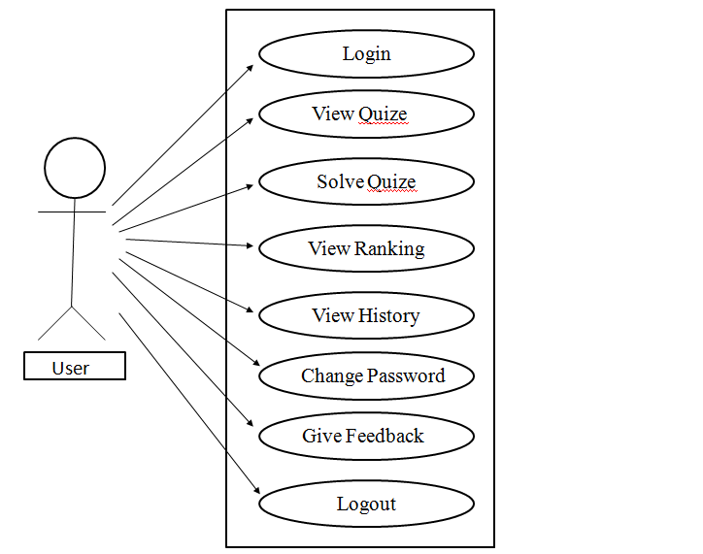

**3.2 Class Diagram**

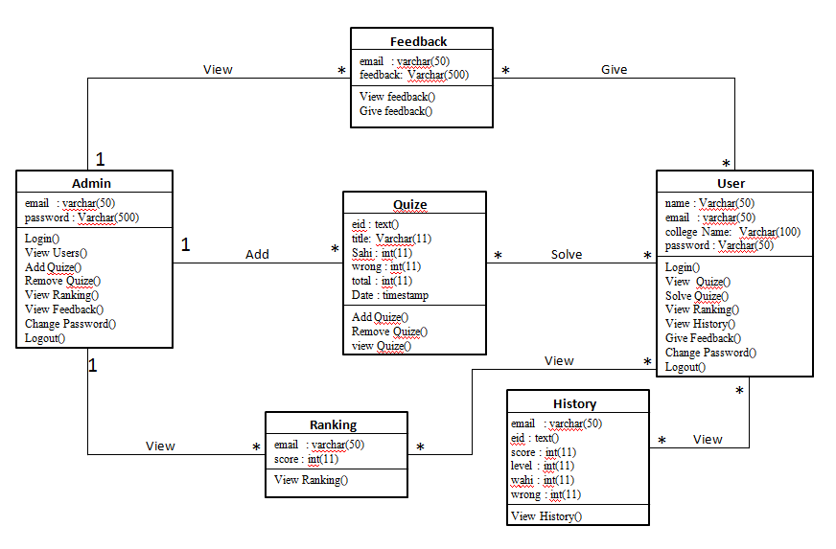

**3.3 Sequence Diagram**

**3.3.1 Admin sequence diagram**

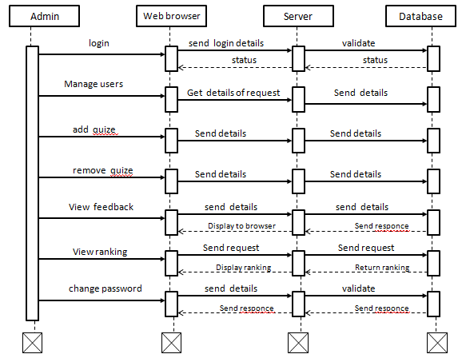

**3.3.2 User sequence diagram**

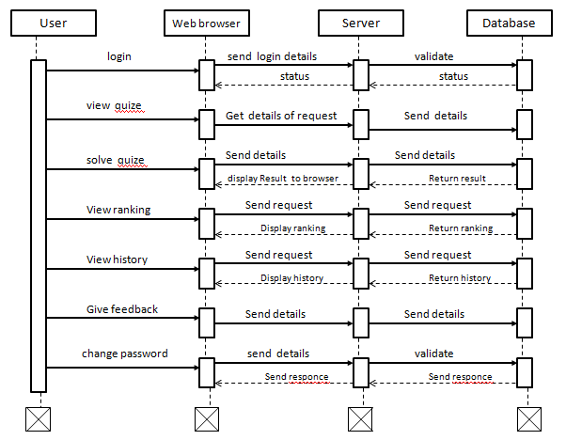

**3.4 Activity Diagram**

**3.4.1 Admin activity diagram**

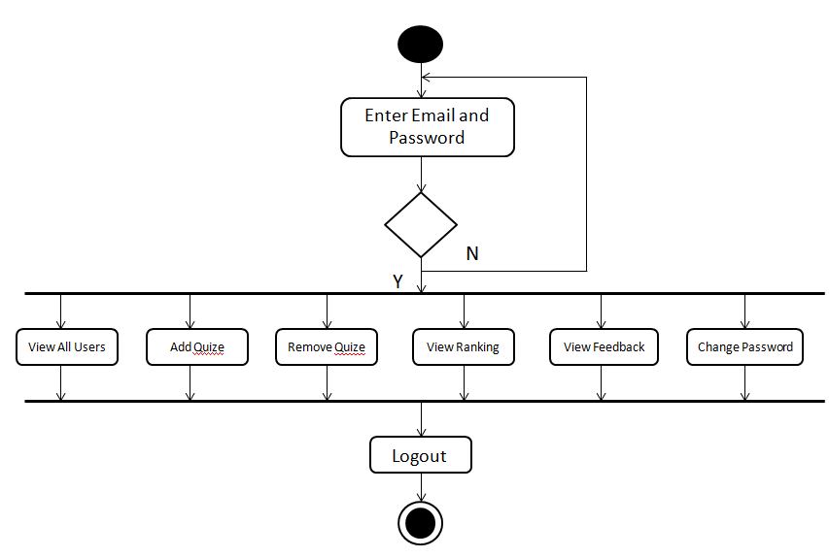

**3.4.2 Admin activity diagram**

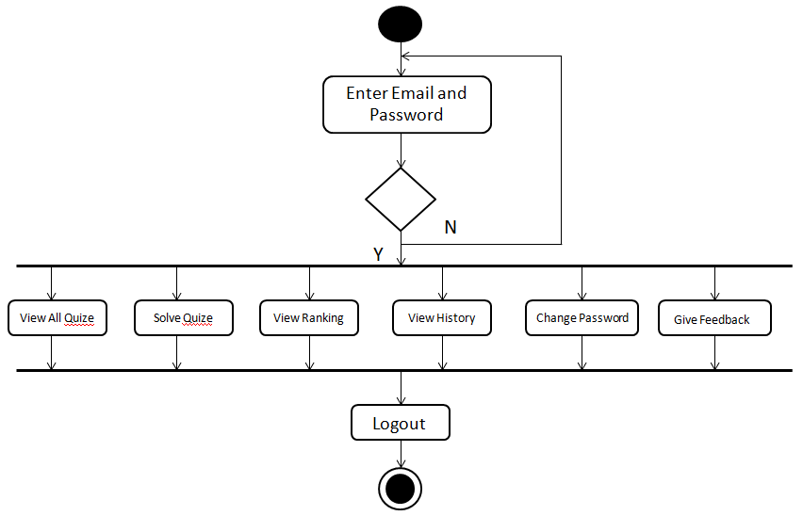

**3.5 Deployment Diagram**

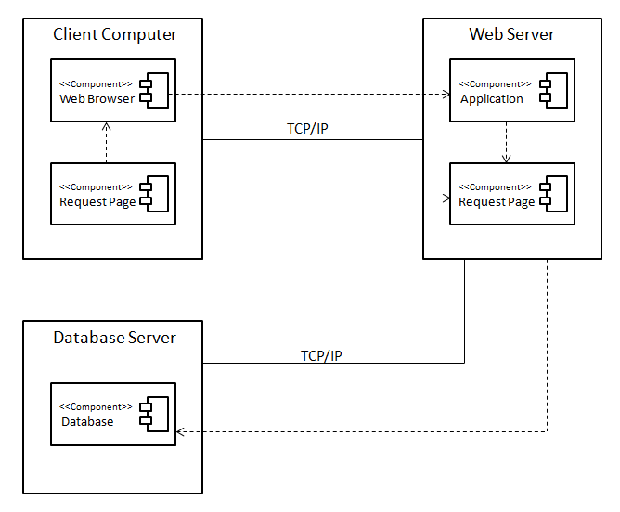

**3.6 Entity Relationship Diagram (ERD)**

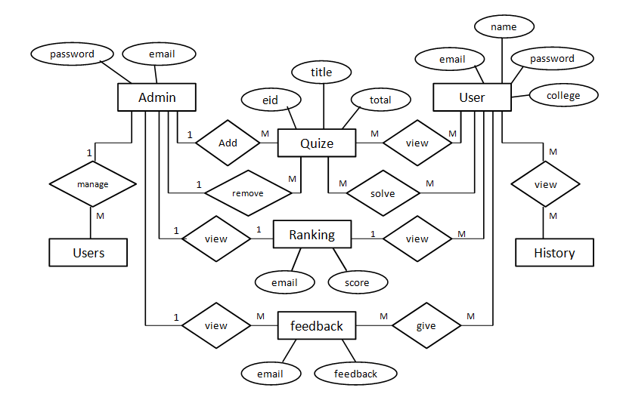

**3.7 User Interface**

**Home Page**

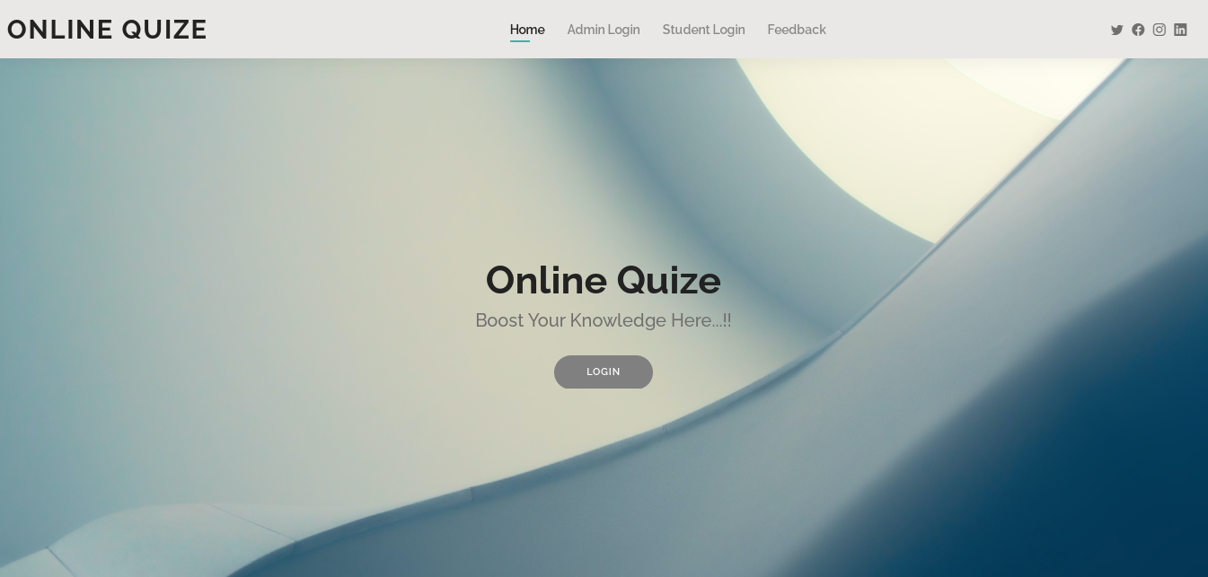

**User Registration Page**

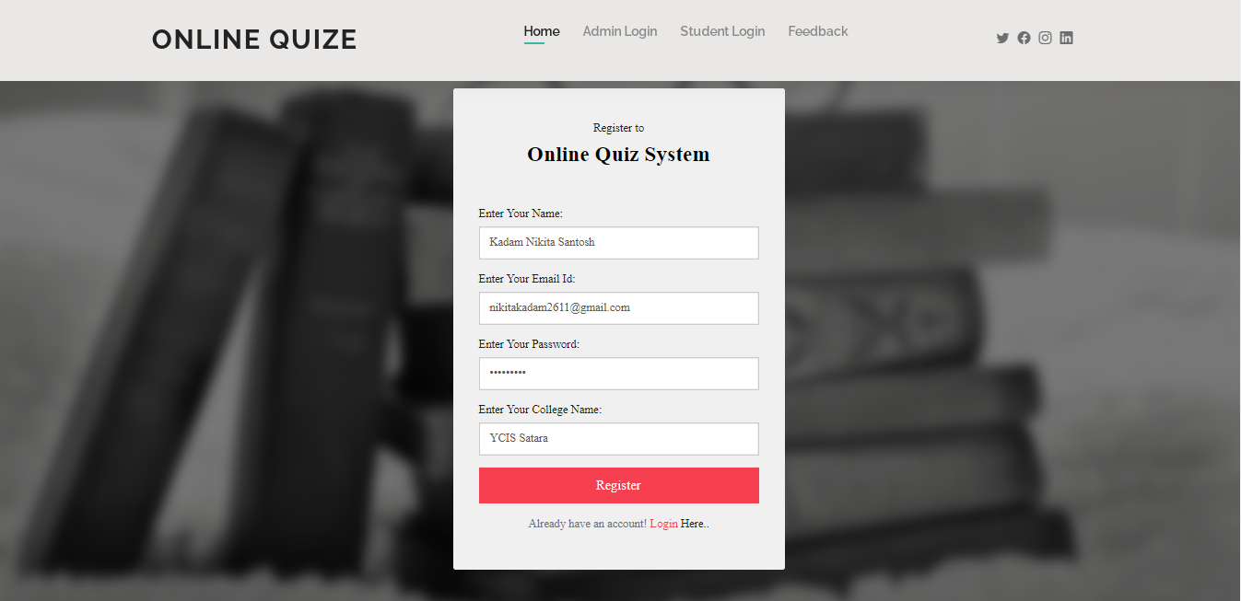

**Admin Login Page**

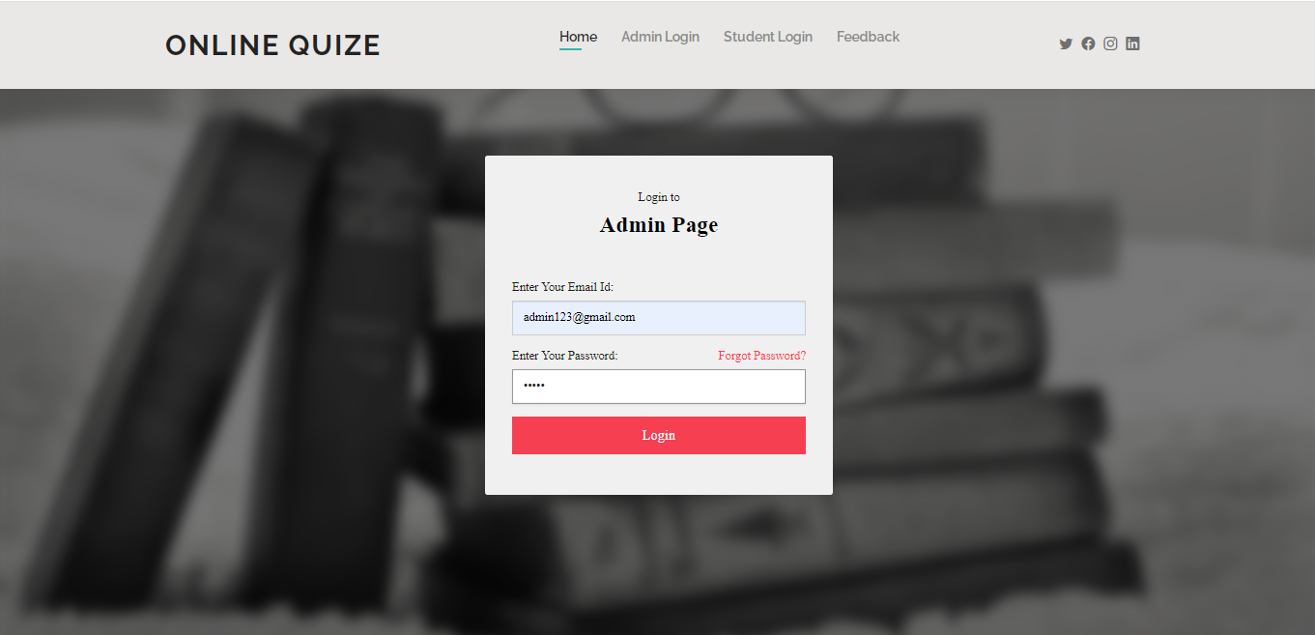

**User Login Page**

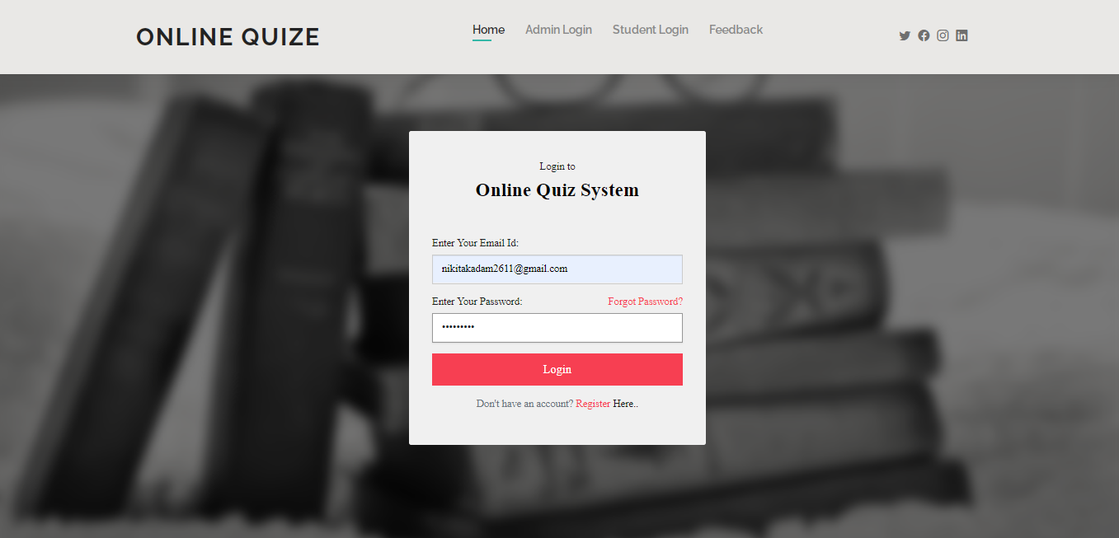

**Admin Forgot Password Page**

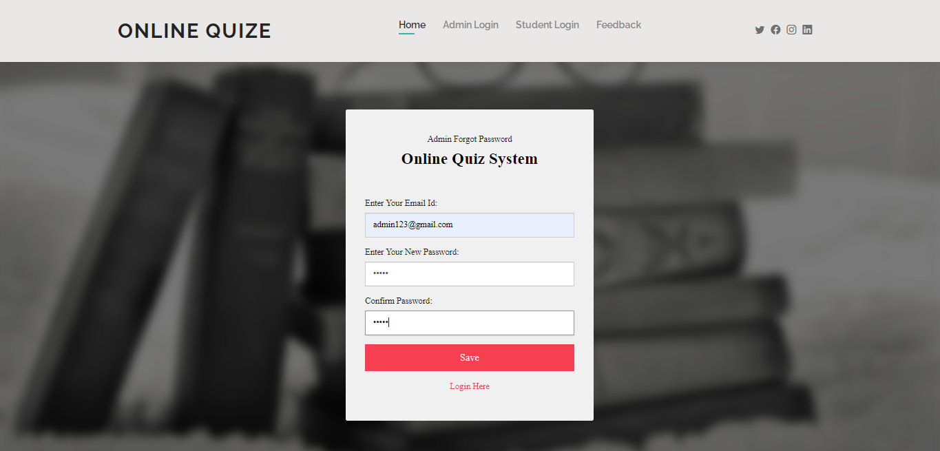

**User Forgot Password Page**

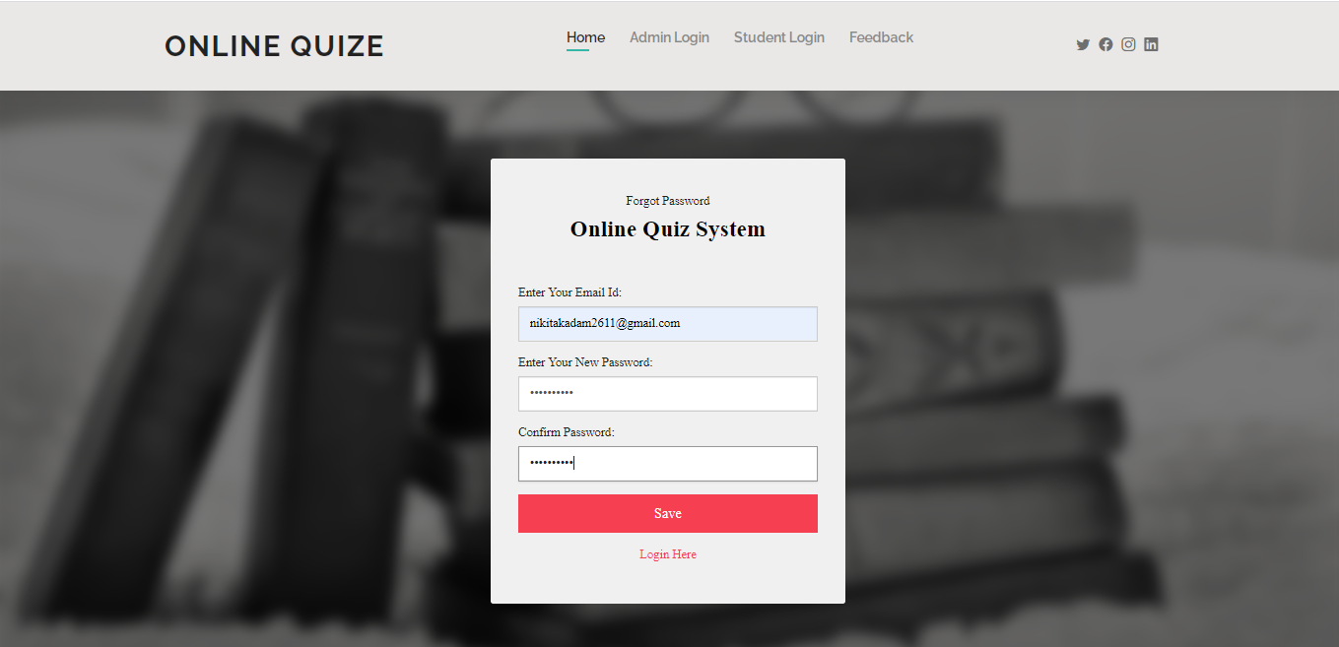

**Feedback Page**

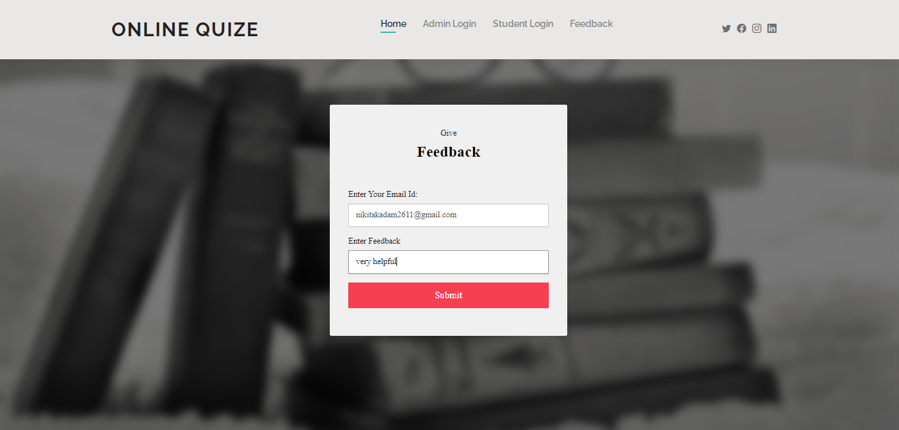

**Admin Home Page**

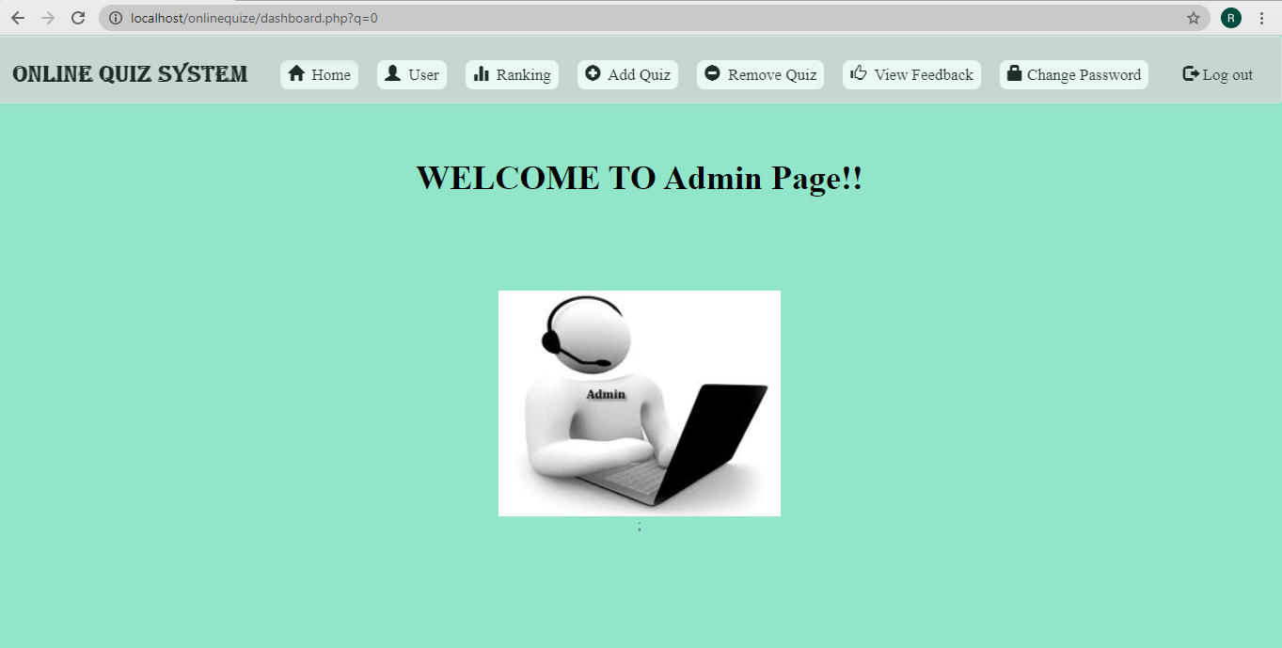

**View Users Page**

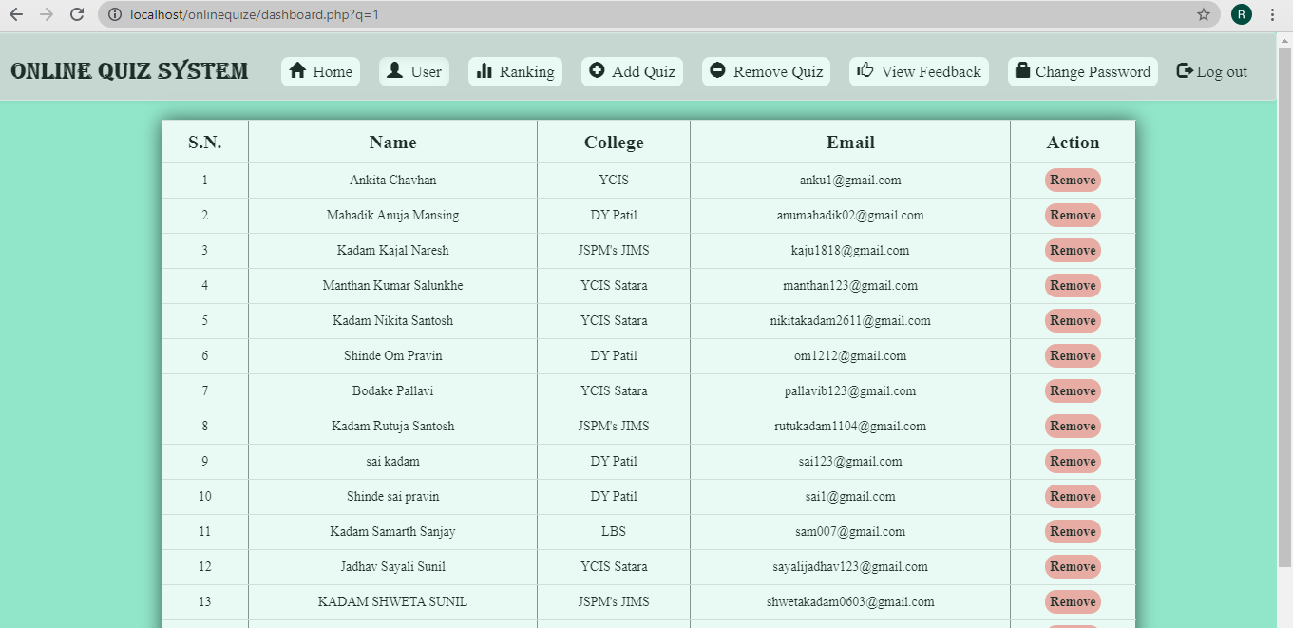

**Add Quiz Page**

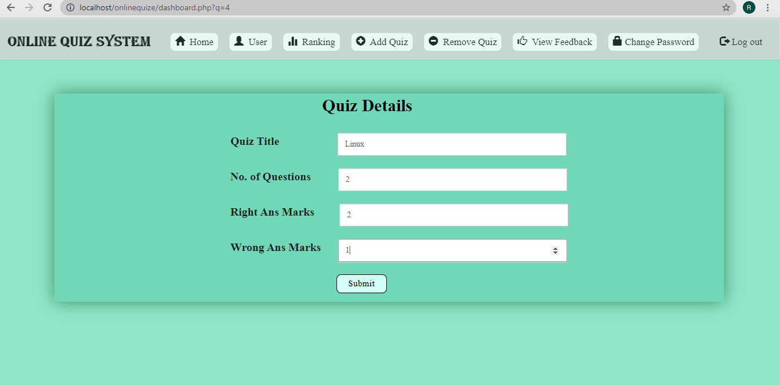

**Add Questions Page**

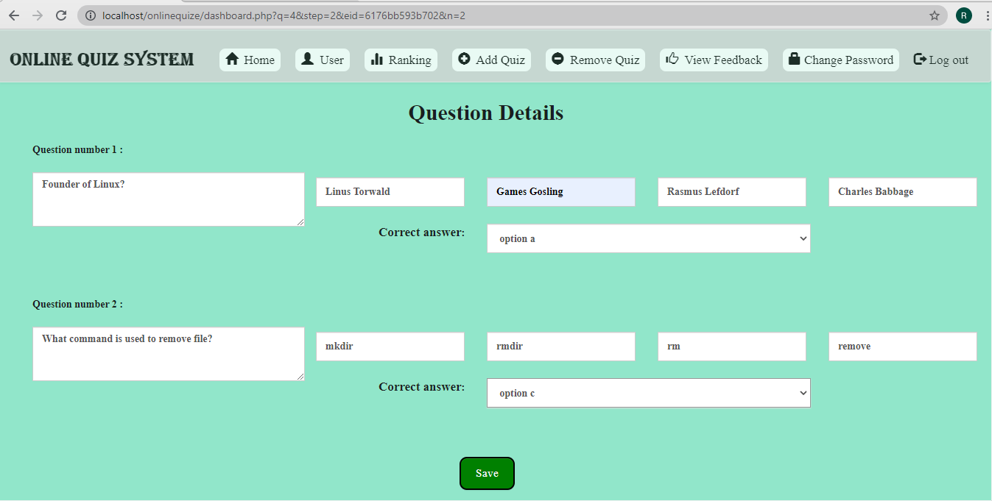

**Remove Quiz Page**

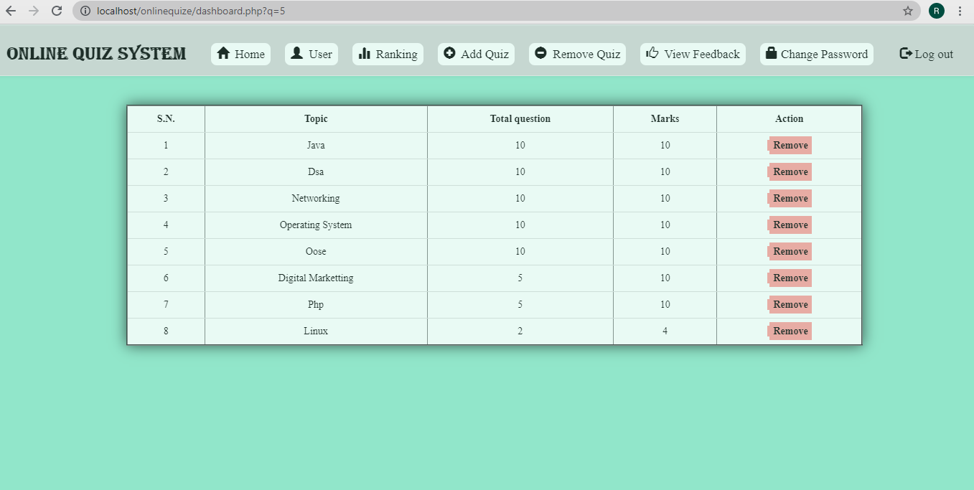

**Ranking Page**

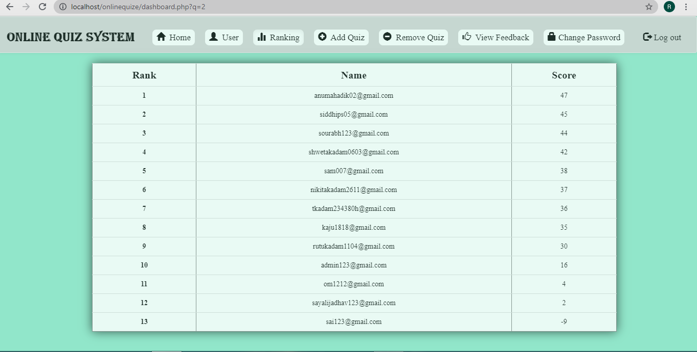

**Feedback page**

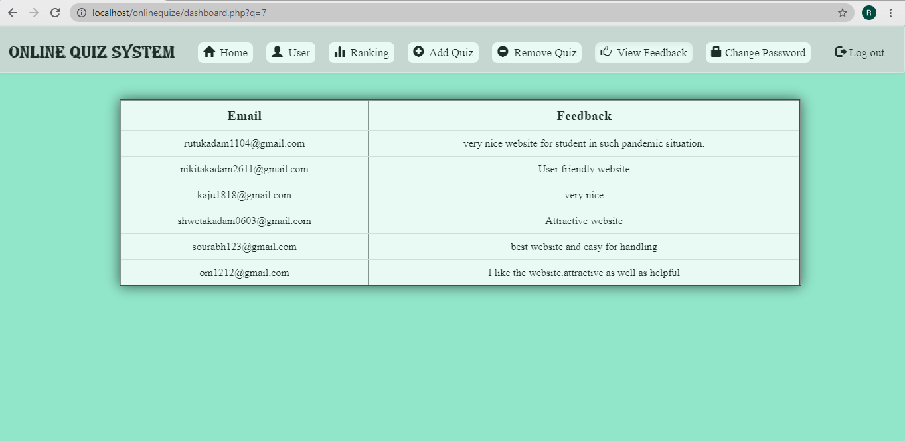

**Change Password for admin**

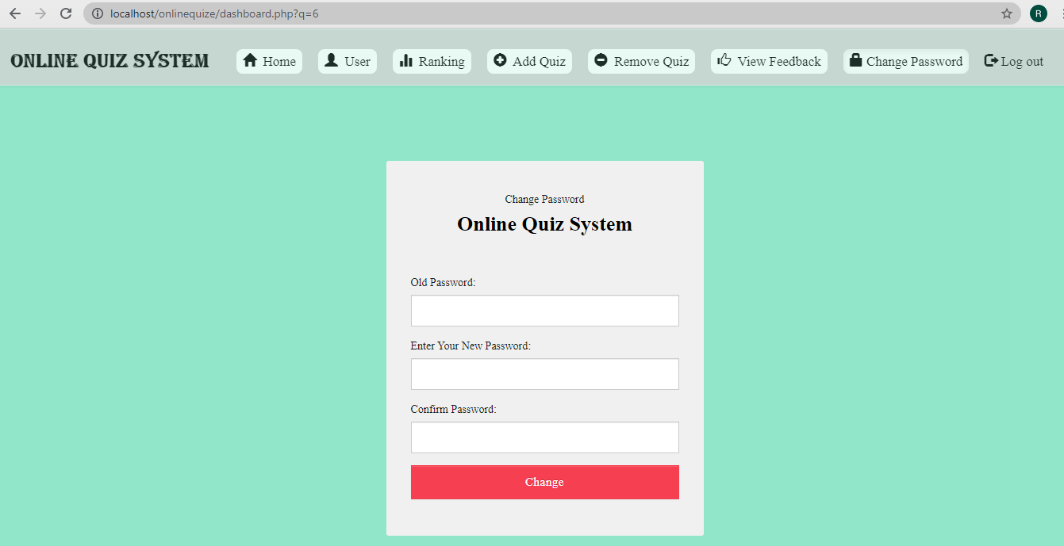

**Home Page**



**Quiz Page**

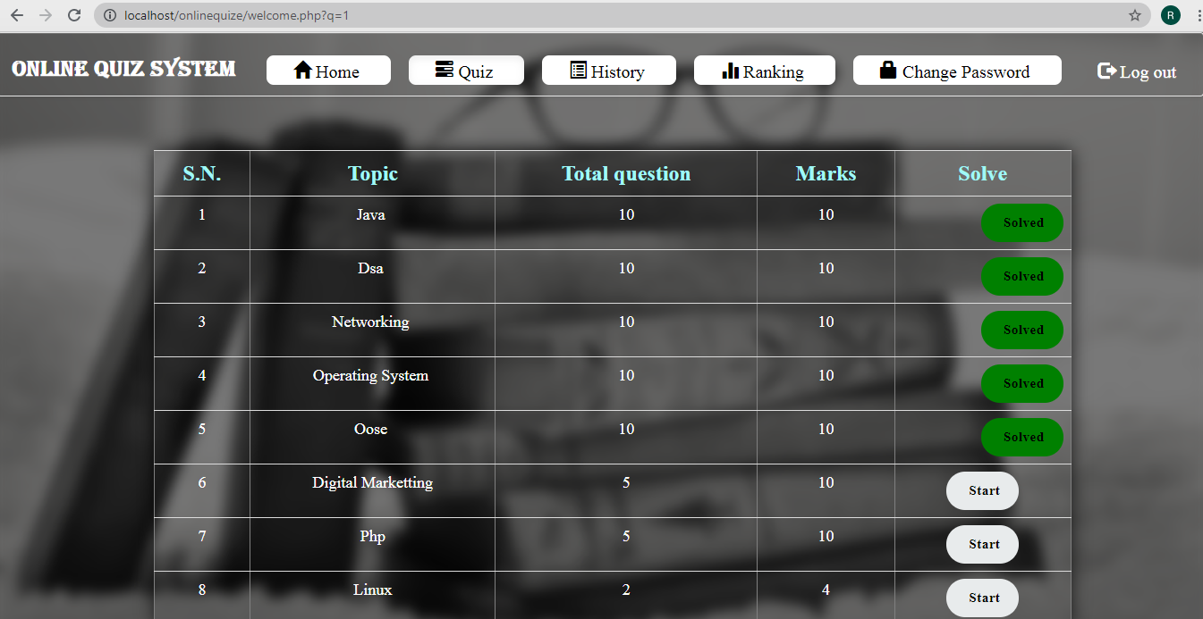

**Solve Quiz Page**

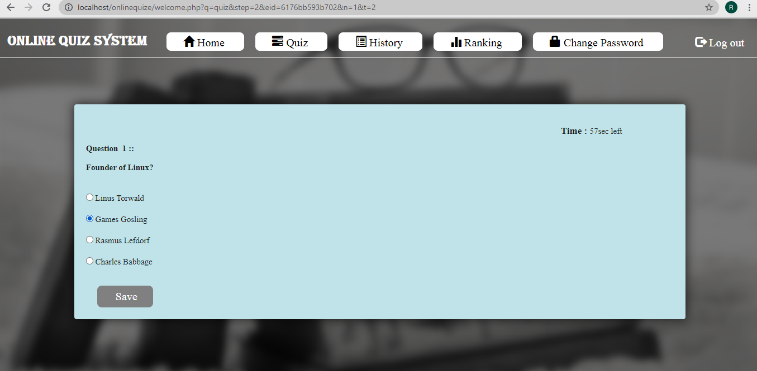

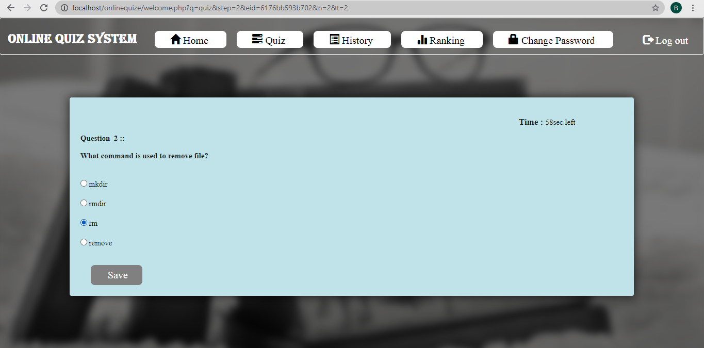

**Result page**

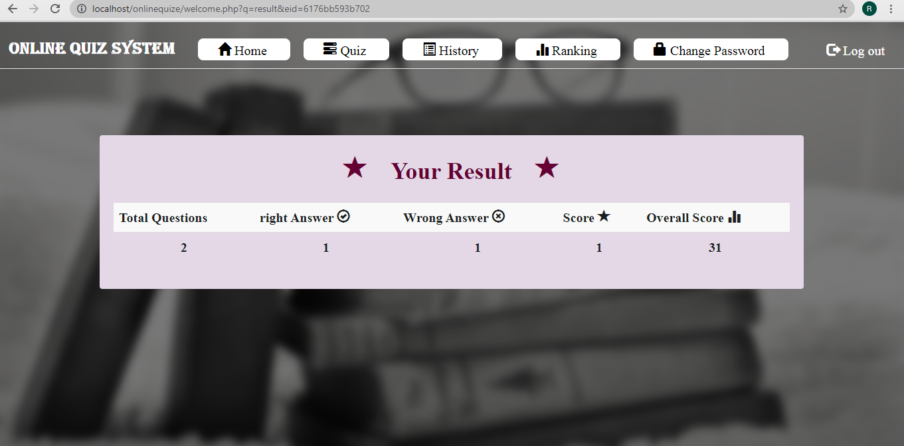

**History Page**

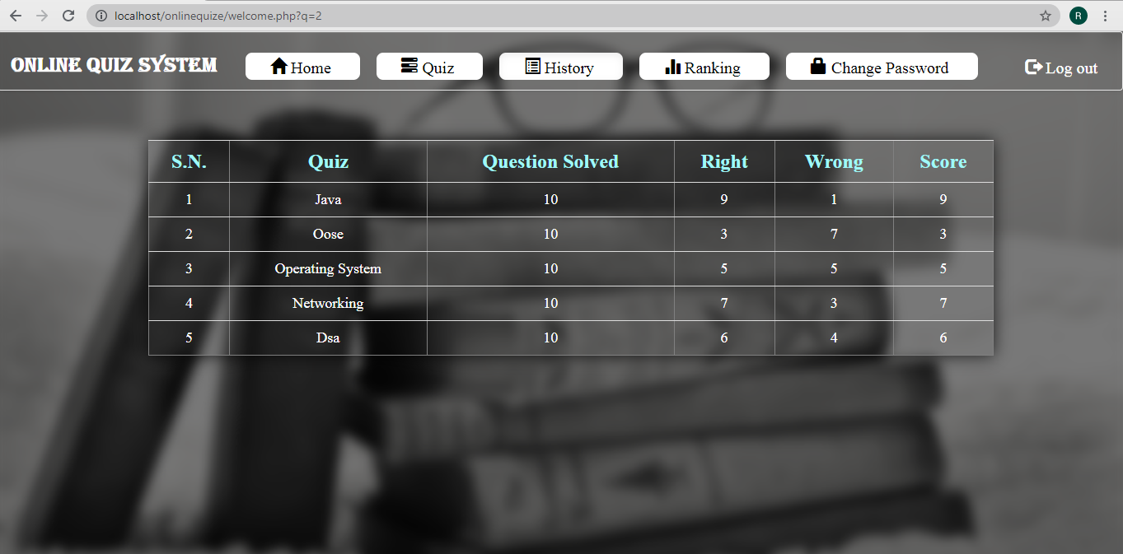

**Ranking Page**

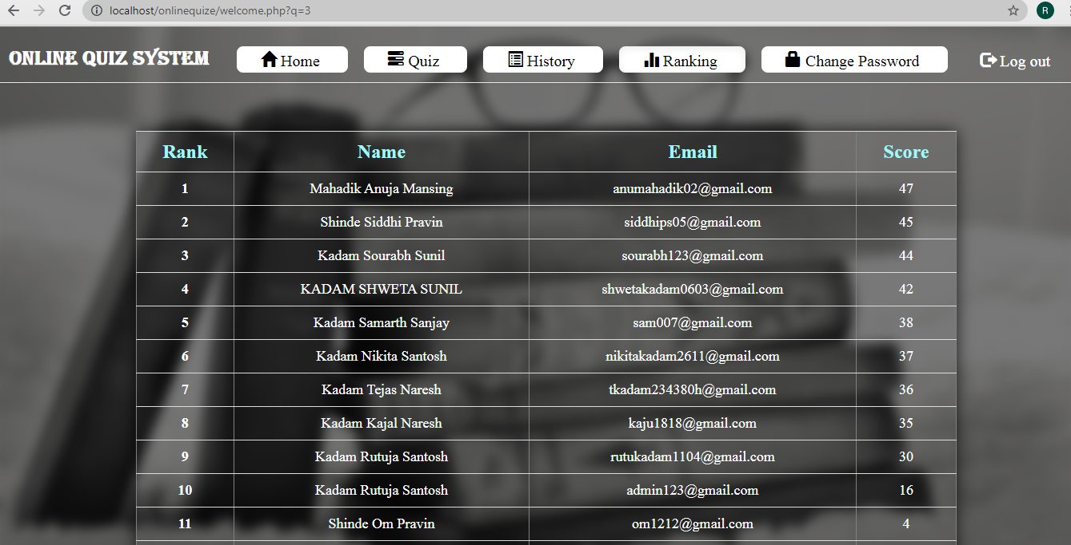

**Change Password Page**

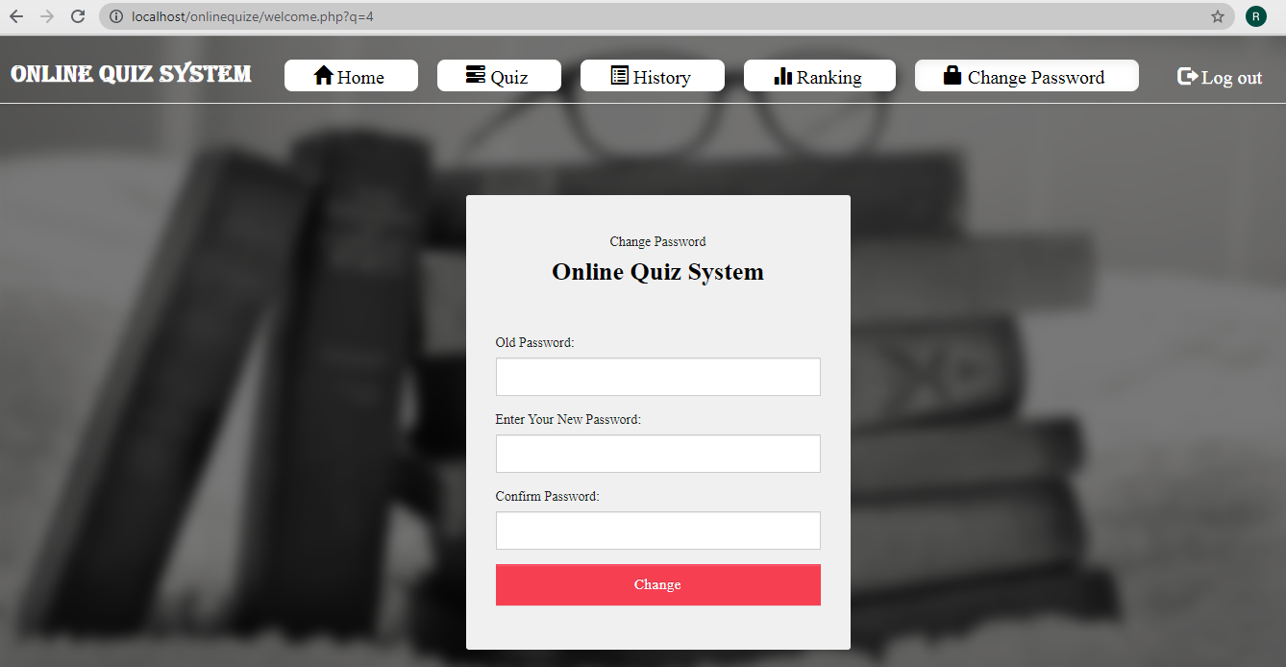

**3.8 Table Specification**

1. **User Registration Table**

|  |  |  |  |
| --- | --- | --- | --- |
| **Column Name** | **Data Type** | **Constraint** | **Description** |
| name | Varchar (50) | NOT NULL | Username |
| college | Varchar (100) | NOT NULL | College Name |
| email | Varchar (50) | Primary Key | E-mail |
| password | Varchar (50) | NOT NULL | Password |

1. **Admin Table**

|  |  |  |  |
| --- | --- | --- | --- |
| **Column Name** | **Data Type** | **Constraint** | **Description** |
| admin_id | Int (11) | NOT NULL | Admin Id |
| email | Varchar (50) | Primary Key | E-mail |
| password | Varchar (50) | NOT NULL | Password |

1. **Questions Table**

|  |  |  |  |
| --- | --- | --- | --- |
| **Column Name** | **Data Type** | **Constraint** | **Description** |
| eid | Text | Foreign Key | Panel Id |
| qid | Text | Primary Key | Question Id |
| qns | Text | NOT NULL | Question |
| choice | Int (10) | NOT NULL | No. of Options |
| sn | Int (10) | NOT NULL | Serial No. |

1. **Options Table**

|  |  |  |  |
| --- | --- | --- | --- |
| **Column Name** | **Data Type** | **Constraint** | **Description** |
| qid | Varchar (50) | Foreign Key | Question Id |
| option | Varchar (5000) | NOT NULL | Options |
| optionid | Text | Primary Key | Option Id |

1. **Quiz Table**

|  |  |  |  |
| --- | --- | --- | --- |
| **Column Name** | **Data Type** | **Constraint** | **Description** |
| eid | Text | Primary Key | Panel Id |
| title | Varchar (100) | NOT NULL | Title of Quiz |
| sahi | Int (11) | NOT NULL | Right Answers |
| wrong | Int (11) | NOT NULL | Wrong Answers |
| total | Int (11) | NOT NULL | Total No.of Question |
| date | Timestamp | NOT NULL | Date |

1. **Answer Table**

|  |  |  |  |
| --- | --- | --- | --- |
| **Column Name** | **Data Type** | **Constraint** | **Description** |
| qid | Text | Foreign Key | Question Id |
| ansid | Text | Primary Key | Answer Id |

1. **Rank Table**

|  |  |  |  |
| --- | --- | --- | --- |
| **Column Name** | **Data Type** | **Constraint** | **Description** |
| email | Varchar (50) | Foreign Key | E-mail |
| score | Int (11) | NOT NULL | Quize Score |
| time | Timestamp | NOT NULL | Time |

1. **History Table**

|  |  |  |  |
| --- | --- | --- | --- |
| **Column Name** | **Data Type** | **Constraint** | **Description** |
| email | Varchar (50) | Foreign Key | E-mail |
| eid | Text | Foreign Key | Title of Quiz |
| score | Int (11) | NOT NULL | Quize Score |
| level | Int (11) | NOT NULL | No. of Solved Que |
| sahi | Int (11) | NOT NULL | Right Answers |
| wrong | Int (11) | NOT NULL | Wrong Answers |
| date | Timestamp | NOT NULL | Date |

1. **Feedback Table**

|  |  |  |  |
| --- | --- | --- | --- |
| **Column Name** | **Data Type** | **Constraint** | **Description** |
| email | Varchar (50) | Foreign Key | E-mail |
| feedback | Varchar (500) | NOT NULL | Feedback |

**4.1 Drawbacks & Limitations**

Each and every system has some limitations that can restrict then to work on a particular environment. Through our system is provided high amount of accuracy and quick data generation there is still some limitations that led us to in greater deficiency to work on that system. Some of the limitation that is observed during althe process is mentioned below.

* The system is web-base application (website) so internet facility must be need.
* This system is a web-base system so it may slow when more users accessing same Interface at same time.
* Susceptible to Cheating
* Current system provides only multiple choices but single currect answer selection.

**4.2 Proposed Enhancement**

* Next we are aiming to provide facility to admin to modify the any question from any quize.
* This project is only for MCQ test but in the future we have plan to extended it to support subjective type of questions with more functionality.
* Develop discussion forums
* We will add time limitation to the quize.

**Conclusion**

This online quize system provides facility to conduct online quize world wide. It saves time as it allows number of students to give the exam at a time and displays the results as the test gets over, so no need to wait for the result. It is automatically generated by the server. Administrator has a privilege to create and delete the test papers and its particular questions. User can register, login and give the test with his specific id, and can see the results as well.

**Bibliography**

* **WEBSITES**
* http://books.google.com
* http://www.projectcode.com
* http://www.W3Schools.com
* http://www.stackoverflow.com
* http://www.getbootstrap.com